Design Patterns
- Design pattern Proxy:
Illustrating code snippet:
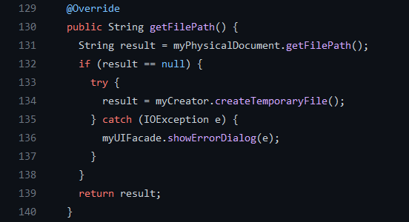
Class location: ganttproject/ganttproject/src/main/java/net/sourceforge/ganttproject/document/ProxyDocument.java
Explanation: The ProxyDocument.java class performs the same tasks as Document object, but may delegate requests to the Document object to achieve them

- Design pattern Factory:
Illustrating code snippet:
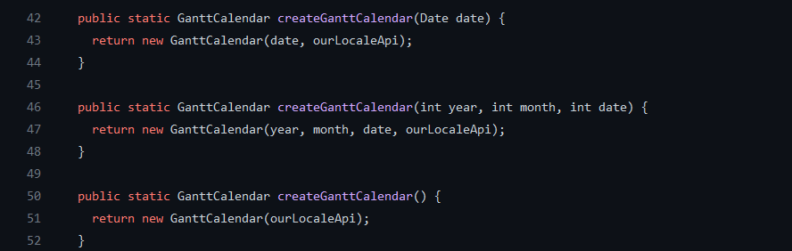
Class location: ganttproject/biz.ganttproject.core/src/main/java/biz/ganttproject/core/time/CalendarFactory.java
Explanation: The CalendarFactory.java class hide the creation of GanttCalendar objects

- Design pattern Façade:
Illustrating code snippet:
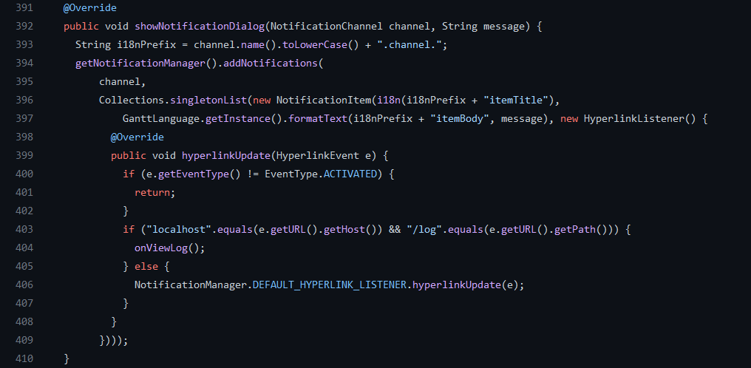
Class location: ganttproject/ganttproject/src/main/java/net/sourceforge/ganttproject/UIFacadeImpl.java
Explanation: The UIFacadeImpl.java is a class that encapsulates a subsystem to hide the subsystem’s complexity (e.g., the showNotificationDialog method hides from the user how the notification will be created and displayed), and acts as a point of entry into a subsystem without adding more functionality in itself (e.g., the showNotificationDialog method uses the NotificationManager subsystem and no extra functionality is added to the class)

